WIPRO CAPSTONE PROJECT
BlazeDemo Flight Booking Application Automation Documentation

Prepared By: Baivab Sarkar
Mentor/ Trainer: Vaishali Sonanis
Framework: Selenium + Java + TestNG + Maven + Page Object Model (POM) + Thread Local
GitHub Link: https://github.com/ThisIs-Developer/Wipro-Capstone-Project
BlazeDemo URL: https://blazedemo.com/

1. Introduction
BlazeDemo is a demonstration web application that simulates an end-to-end airline ticket booking workflow. Users can browse available flights between origin and destination cities, select a preferred flight, complete passenger and payment details, and receive a booking confirmation upon successful purchase. The primary objective of this project is to validate the functional correctness and stability of each workflow stage through a structured automation framework.

2. Technology Stack
- Automation Stack: Java, Selenium WebDriver, TestNG, Apache Maven
- Framework Architecture: Page Object Model (POM), Factory Pattern
- Test Data & Configuration: Apache POI (Excel), Configuration Properties Files
- Reporting & Monitoring: ExtentReports, Log4j2 Logging Framework
- Source Control: Git, GitHub
- DevOps & CI/CD: Jenkins, Docker
- Development Environment: Eclipse IDE

3. Framework Structure
- base/ (Framework Base): Handles browser setup, WebDriver initialization, and test teardown.
- pages/ (Page Objects): Contains page elements and actions for each application page.
- testcases/ (Test Scripts): Stores functional and negative test scenarios.
- utilities/ (Helper Classes): Provides reusable utilities for Excel, configuration, waits, logging, screenshots, and reporting.
- listeners/ (Execution Listener): Captures test events.
- resources/ (Test Resources): Stores configuration files and test data.
- reports/ (Test Reports): Contains generated ExtentReports after execution.
- screenshots/ (Execution Evidence): Stores screenshots captured during test runs.
- DevOps Files: Includes Dockerfile for containerization and Jenkinsfile for CI/CD automation.

4. Automated Test Flow
- Launch BlazeDemo application using the configured URL.
- Select Departure and Destination cities using Excel test data.
- Search and select a flight from the available flight results.
- Enter passenger and payment details on the Purchase page.
- Complete the booking process and navigate to the Confirmation page.
- Validate booking details such as confirmation message, Booking ID, status, amount, and date.
- Capture screenshots and generate execution reports.
- Execute negative test scenarios for Registration, Login, and Purchase pages to verify application validation behavior.

5. Features to be Tested
The following application components and UI elements are within the scope of this test plan:
Module | Components
Home Page | Page title, departure city dropdown, destination city dropdown, Find Flights button
Flight Search Results | Flight availability table, flight listing rows, Choose Flight buttons
Purchase Page | Passenger name, address, city, state, zip code, card type, credit card number, expiry month/year, name on card, Purchase Flight button
Booking Confirmation | Success message, purchase ID, booking status, booking amount, card number, booking date
Negative Scenarios | Invalid login attempts, invalid registration inputs, invalid purchase form submissions

6 Features not to be Tested
The following testing types fall outside the boundary of this test plan and are not executed as part of this engagement:
- Performance and load testing
- Security testing
- Stress and endurance testing
- Mobile responsiveness testing

7. Test Execution Summary
Passenger Name | Departure City | Destination City | Execution Target | Status | Result
Baivab Sarkar | Boston | London | Local Chrome | PASS | Booking Successfully Confirmed
Ayush Sharma | Paris | Rome | Local Chrome | PASS | Booking Successfully Confirmed
Harsh Choudhary | Mexico City | Dublin | Local Chrome | PASS | Booking Successfully Confirmed

Positive Suite
- 3 Passengers
- 4 Test Methods
  - verifyHomePage()
  - verifyFlightSearch()
  - verifyPurchasePage()
  - verifyBookingConfirmation()
Total = 12 executions

Negative Suite
- verifyRegistrationNegative()
- verifyLoginNegative()
- verifyPurchaseNegative()
Total = 3 executions

8. Execution Log Highlights
Application Launch ➔ Flight Search using Excel Test Data ➔ Flight Selection from Search Results ➔ Passenger & Payment Details Submission ➔ Booking Confirmation Validation ➔ Screenshot Capture ➔ Extent Report Generation ➔ Test Execution Completed Successfully.
Negative Testing Flow ➔ Registration Submission ➔ Validation of 419 Page Expired Defect ➔ Login Submission ➔ Validation of 419 Page Expired Defect ➔ Invalid Purchase Data Submission ➔ Booking Confirmation Generated Despite Invalid Inputs ➔ Defect Validation Completed Successfully.

9. Defects Identified During Negative Testing
The following defects were identified and documented in JIRA during negative testing execution:
JIRA ID | Defect Summary
BLAZE-7 | Booking can be completed with fields left blank
BLAZE-8 | Purchase Flight Form does not perform input validation on passenger and payment information
BLAZE-9 | Month field accepts invalid values outside the valid range
BLAZE-10 | Expired year (1900) displayed as default credit card expiry year
BLAZE-11 | Mandatory fields are not visually identified
BLAZE-12 | Credit Card Number field does not enforce minimum and maximum length validation
BLAZE-13 | Login and Registration pages return "419 Page Expired" error

10. Defects Logged in JIRA:
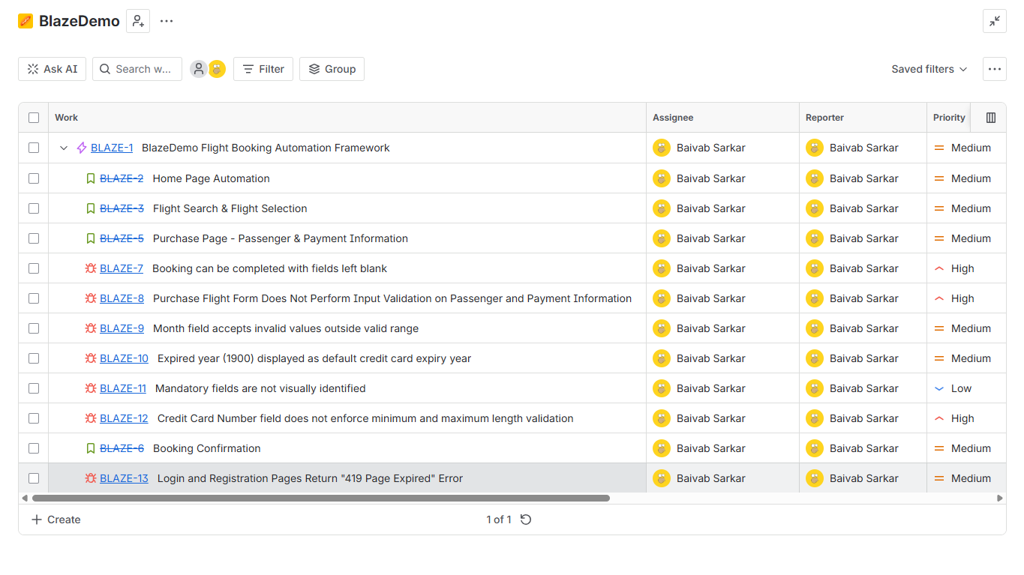

JIRA ID: BLAZE-7
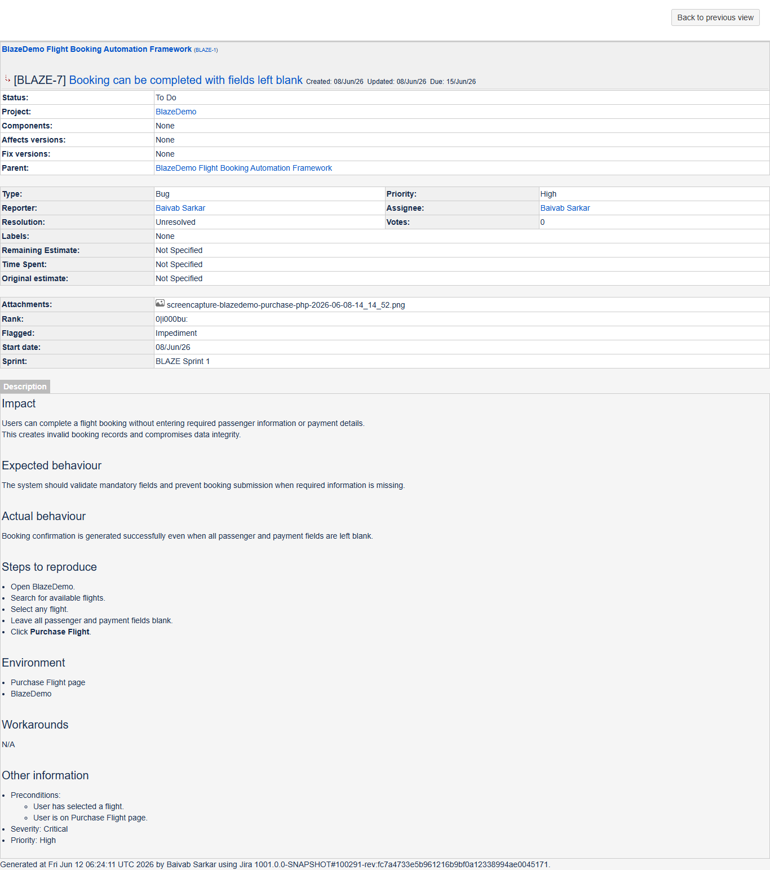
JIRA ID: BLAZE-8
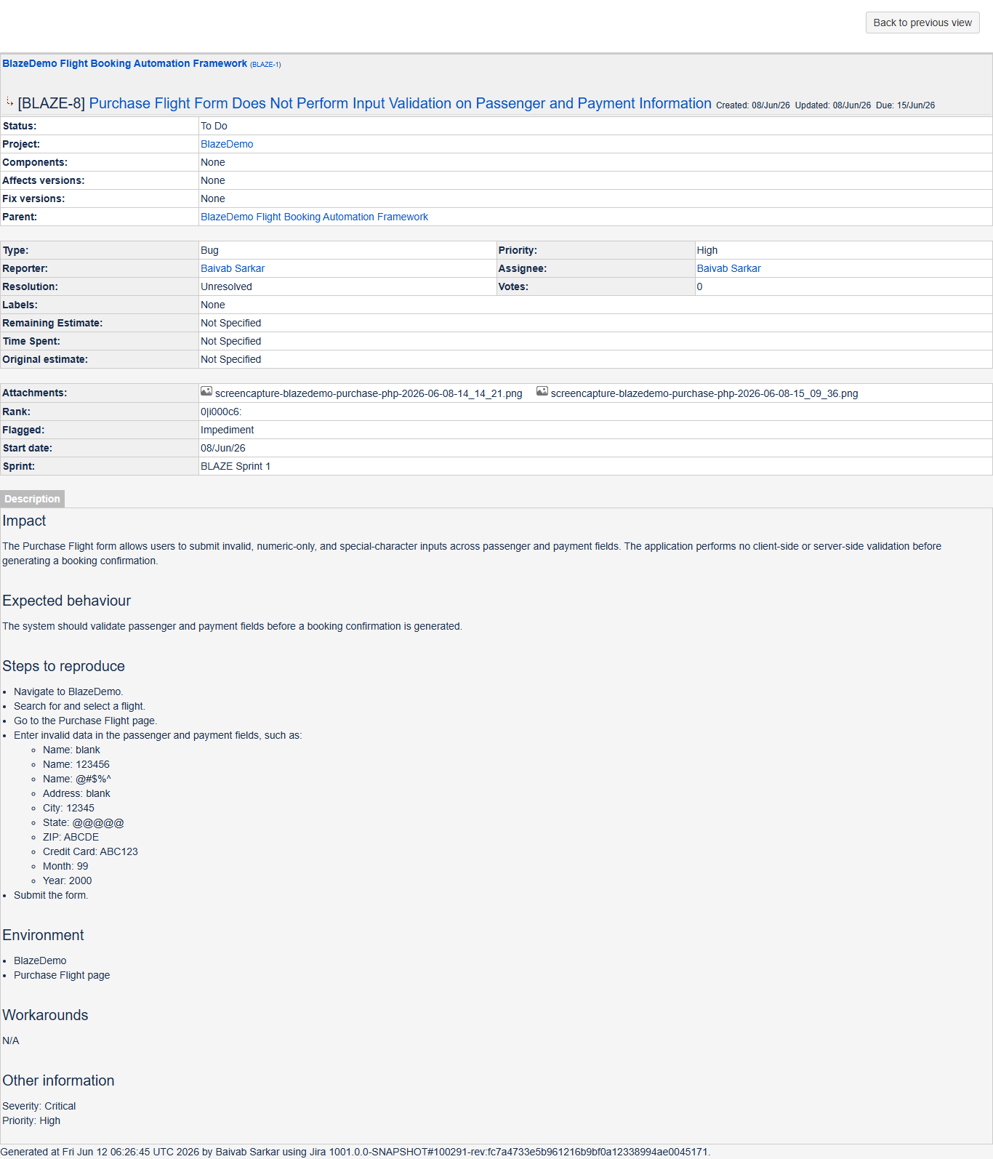
JIRA ID: BLAZE-9
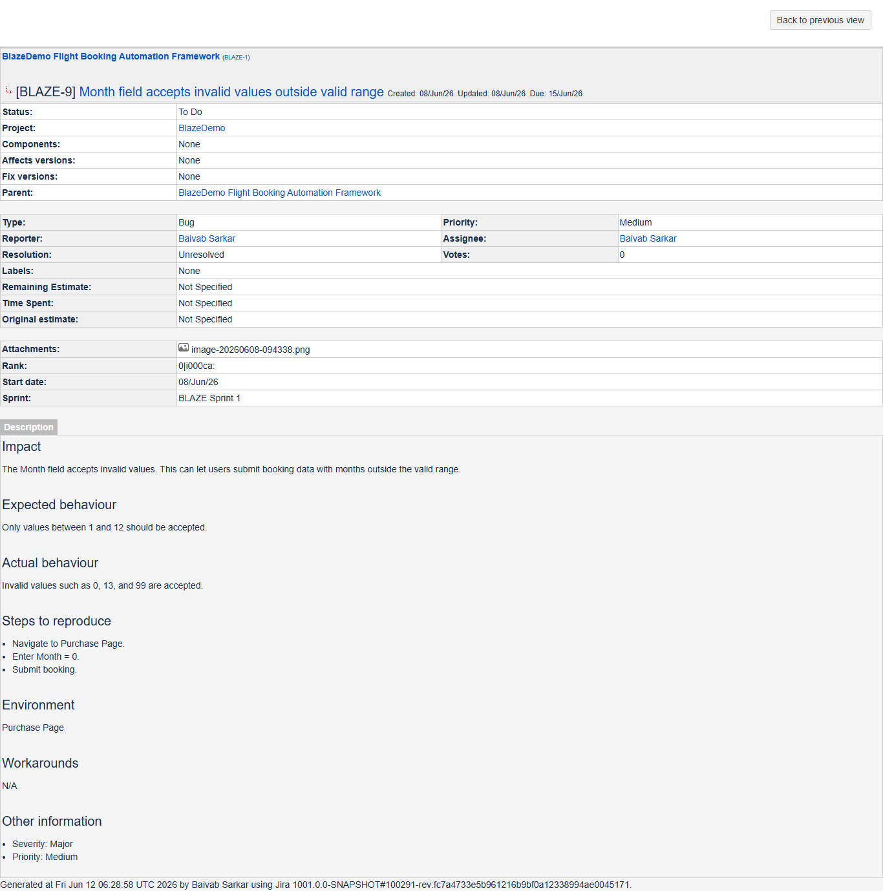
JIRA ID: BLAZE-10
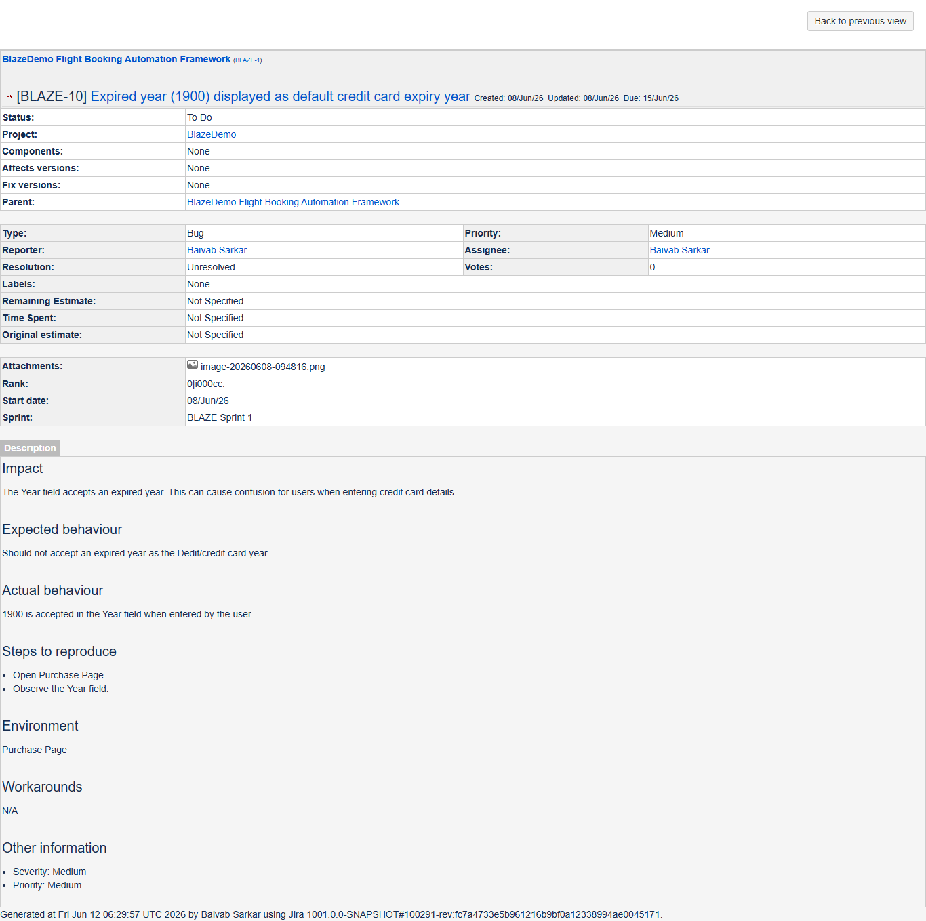
JIRA ID: BLAZE-11
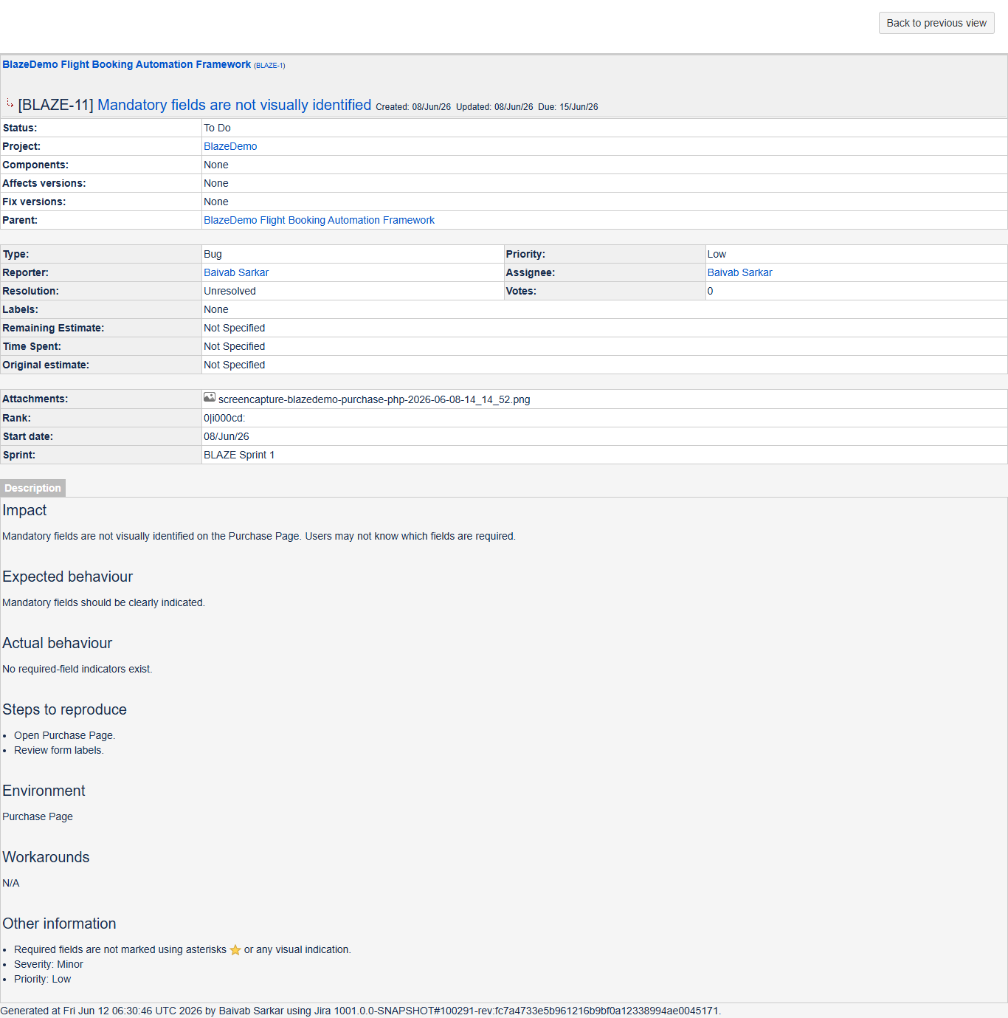
JIRA ID: BLAZE-12
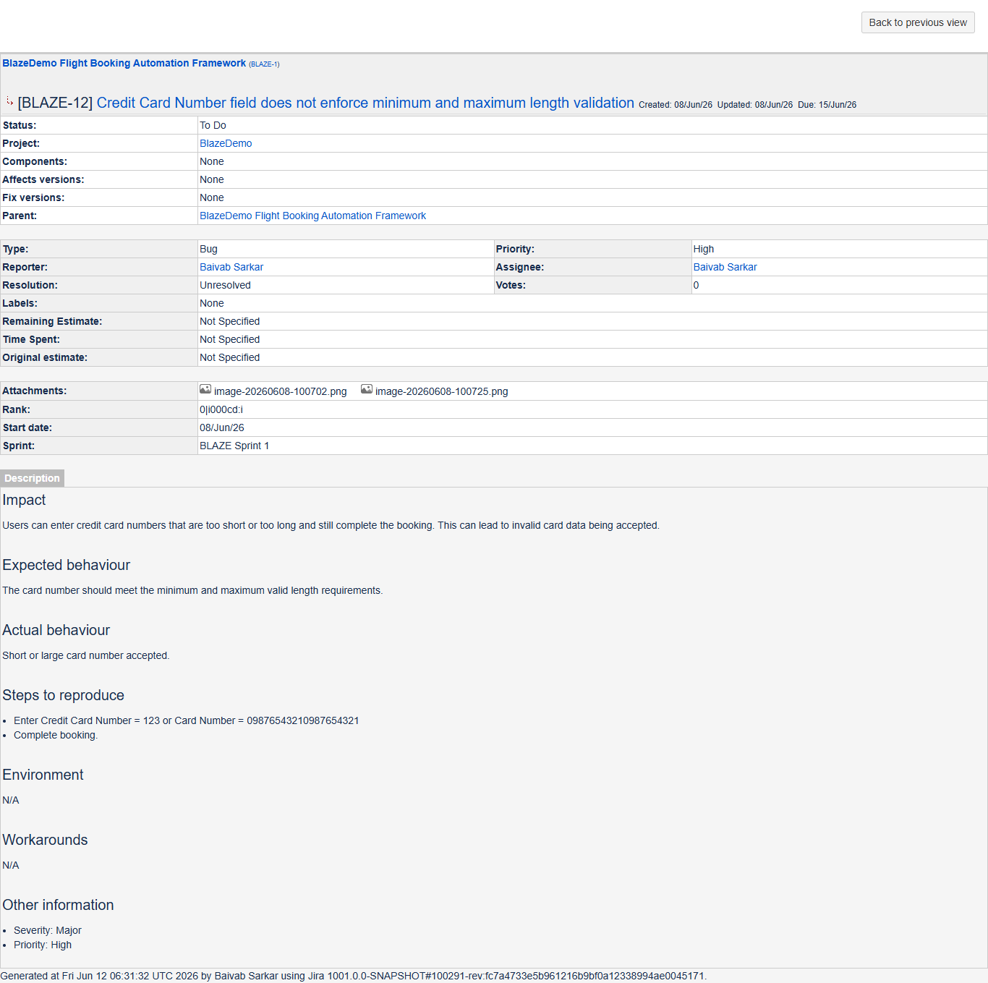
JIRA ID: BLAZE-13
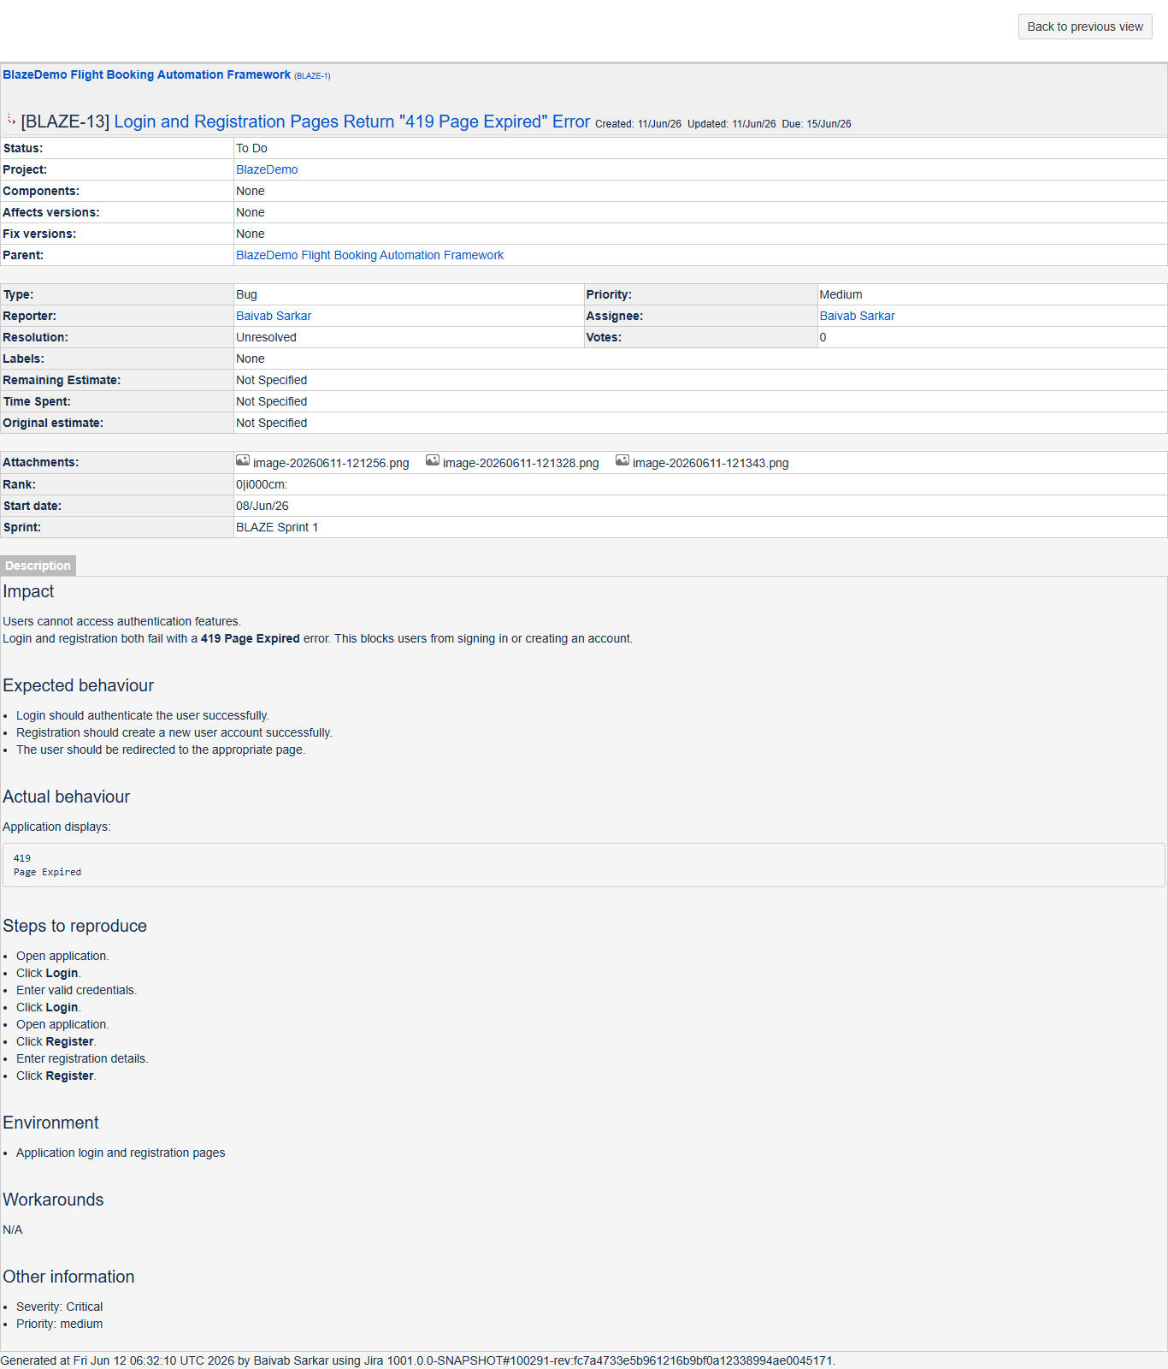

12. Project link & Screenshots & Evidence
Extent Reports, TestNG Reports, screenshots, and execution logs are generated automatically and made available after each execution for analysis and traceability.
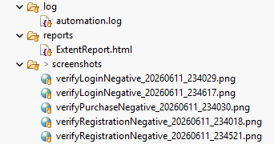

Run as TestNG Suite in IDE

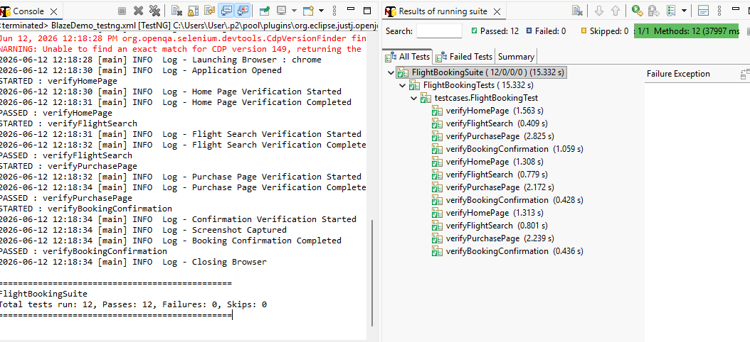
ExtentReport (.html)

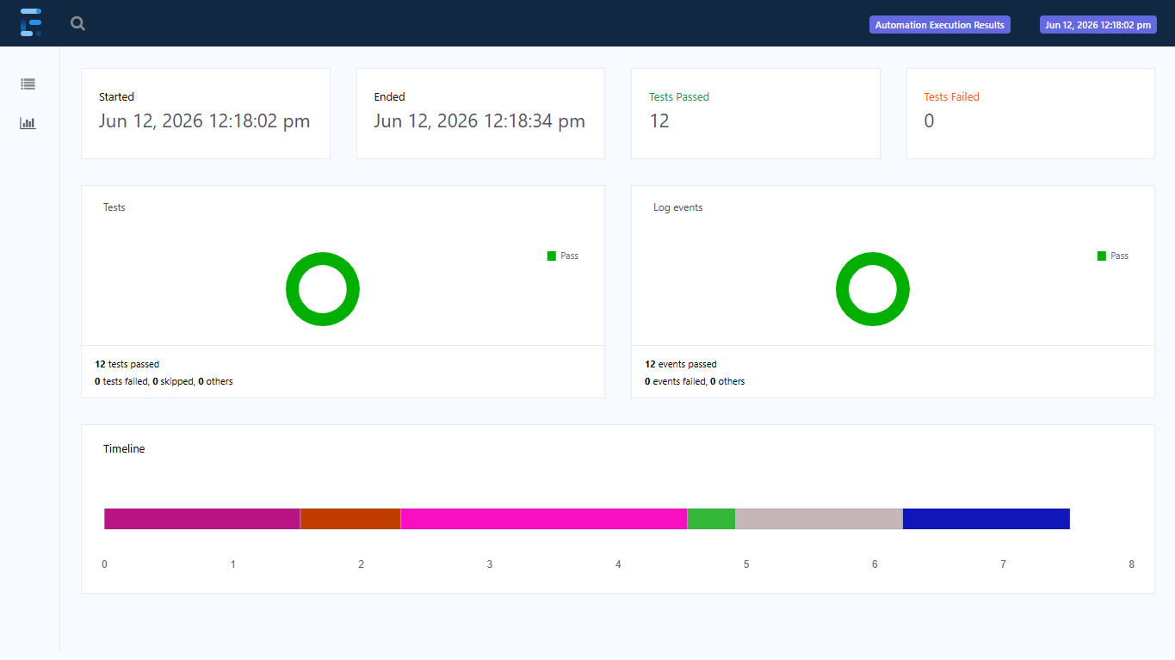

13. CI/CD & Containerization
The automation framework is designed for easy execution across different environments and supports automated build and test execution through containerization and CI/CD integration.
- Jenkins (CI/CD Pipeline):
A Jenkins pipeline is configured to automate the testing workflow. The pipeline pulls the latest code from the Git repository, builds the Maven project, executes the TestNG test suites, generates execution reports, and archives test artifacts for review.
- Docker (Containerization):
The framework is containerized using a custom Dockerfile, allowing the complete Selenium-TestNG automation suite to run inside a Docker container. This ensures a consistent execution environment and eliminates machine-specific dependency issues.
Jenkins runs
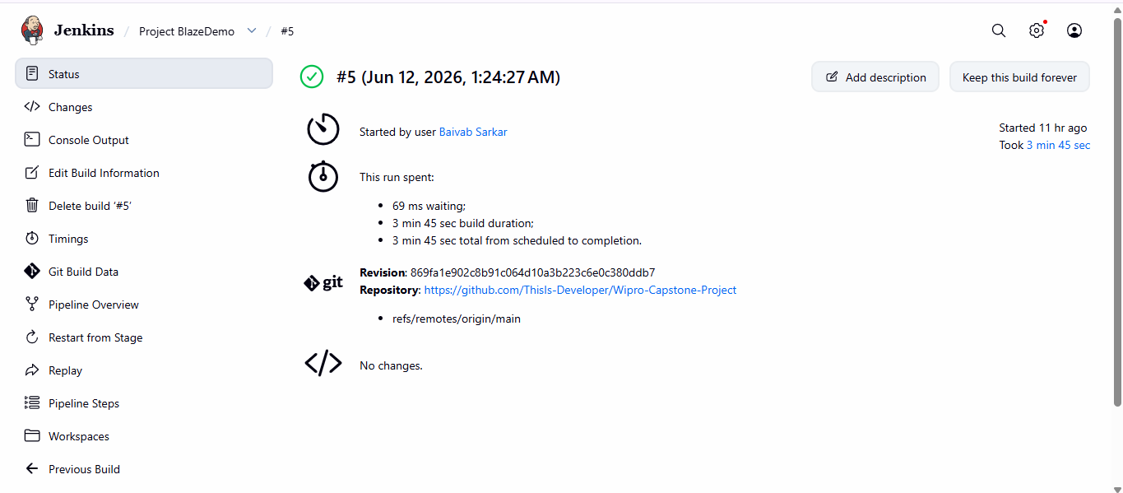
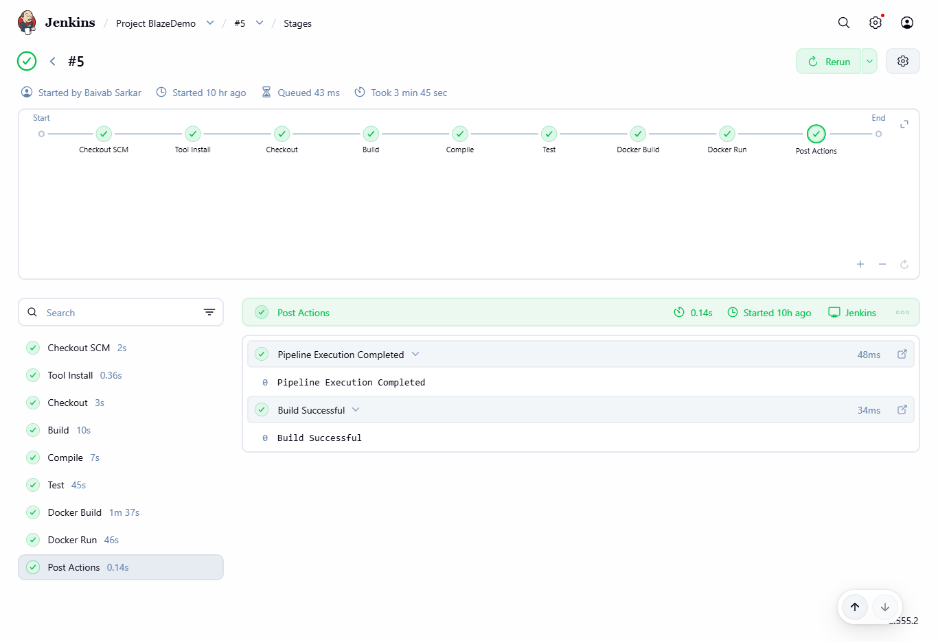
Docker Image Run and Logs

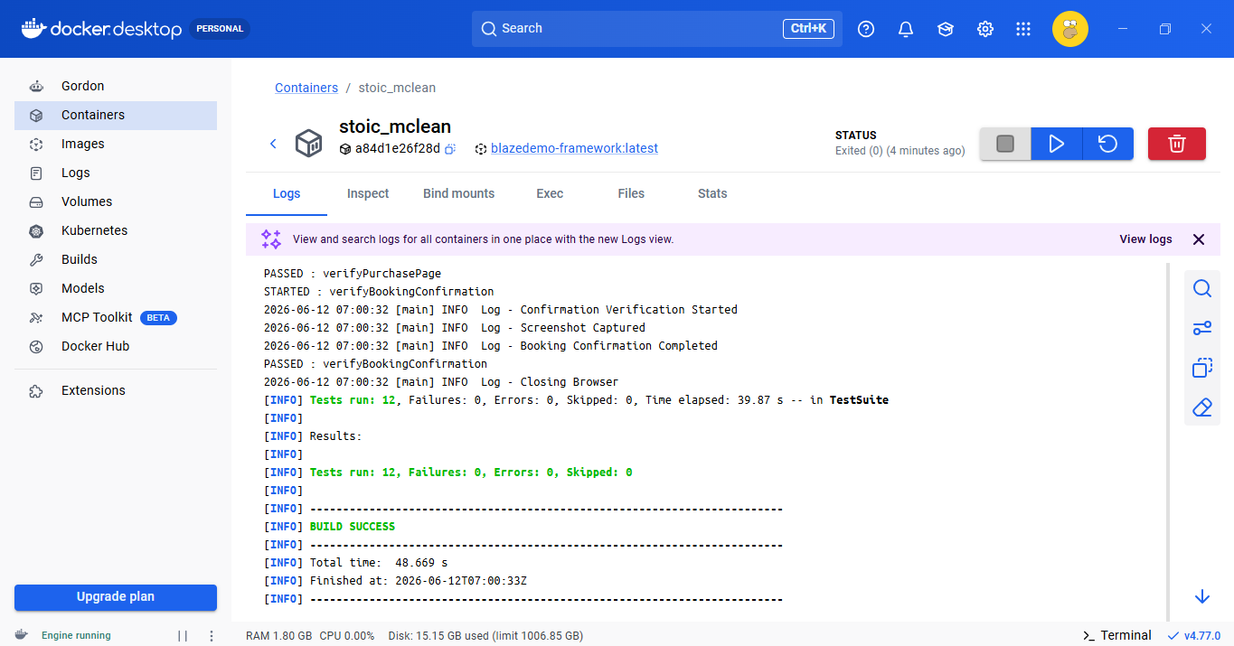

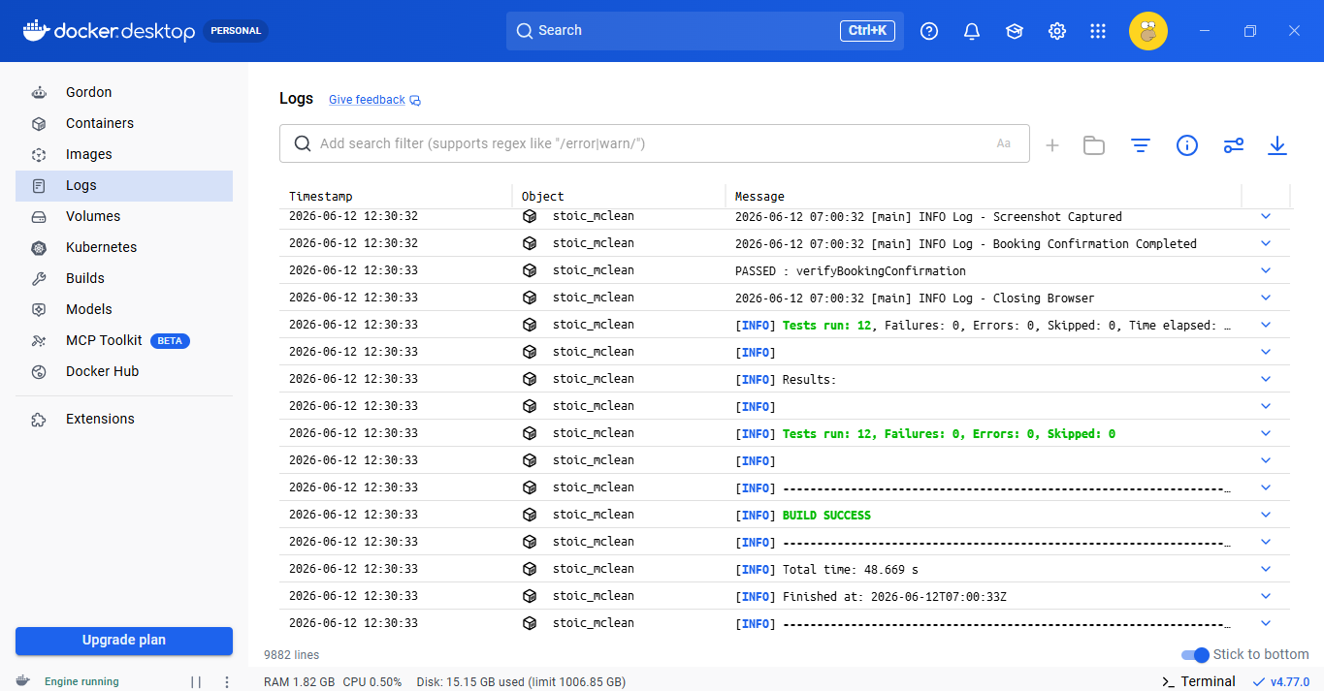

14. Conclusion
The BlazeDemo Automation Framework was successfully developed using Selenium WebDriver, Java, TestNG, Maven, and the Page Object Model (POM) design pattern. The framework supports data-driven testing, automated reporting, screenshot capture, and reusable utilities to improve maintainability and scalability.
The positive test suite successfully validated the complete flight booking workflow for multiple passenger datasets, achieving a 100% execution success rate. In addition, negative testing identified several validation and functional defects, including issues related to form validation, credit card input handling, and authentication pages.
Integration with Docker and Jenkins enabled automated, repeatable, and environment-independent test execution, demonstrating CI/CD readiness. The framework provides clear reporting through Extent Reports and TestNG Reports, ensuring effective test traceability and defect analysis.
Overall, the project demonstrates a robust end-to-end test automation solution capable of validating critical business functionality while efficiently identifying application defects through automated testing practices.

